1. Create a form for IMPORT the attached .xls file
import the file into database (at the “ExaminerDataTable”)

2. Create a input form Name “Head Examiner Selection Form” including following elements:

Subject Code (Auto Search/ Dropdown)
EIIN (Auto Search / Dropdown)
Teacher's Nid (Auto Search / Dropdown)
Mobile No (Auto Search / Dropdown)
Account no (Auto Search / Dropdown)
Institution Name (Auto Search / Dropdown)
Points(Hidden)

Save the Data into a Table Name “Selected_head_examiner_list”
before Save the data you have to ensure value of “points” field.

Points Field data should be calculate using following Criteria:
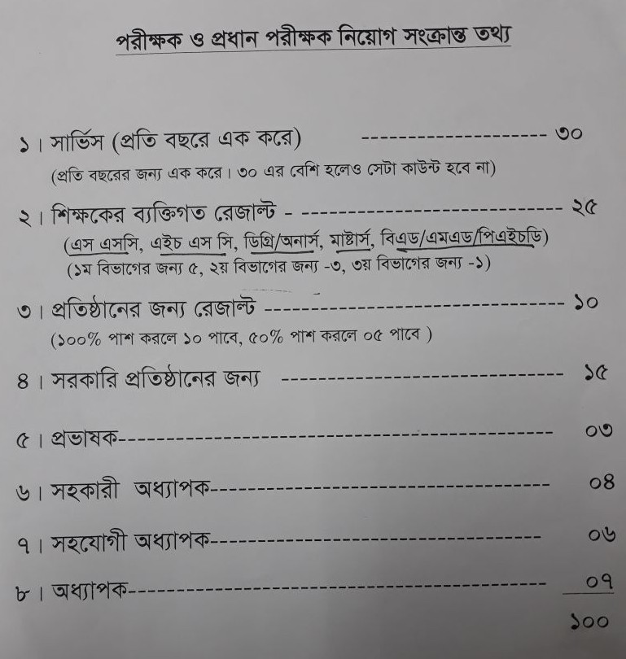

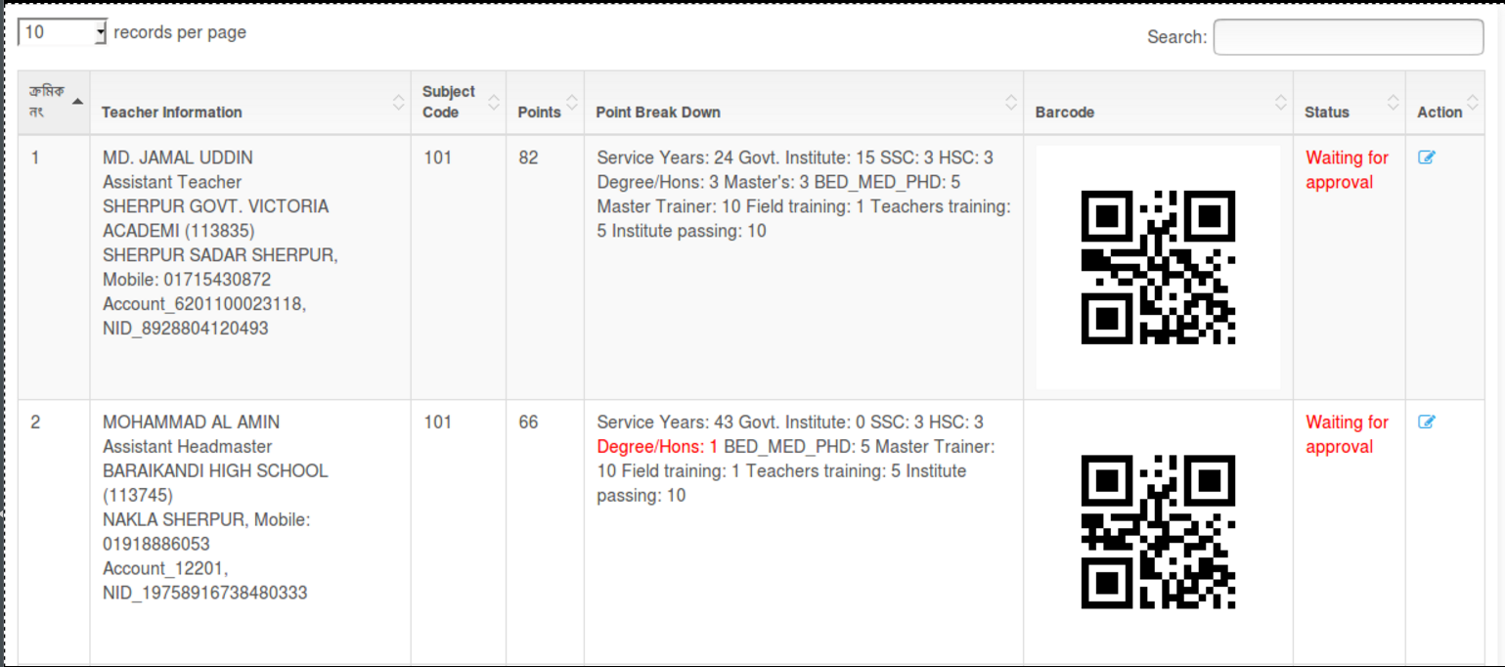
3. show a list of Subject wise Selected Head Examiner
Sample are below:

Note : you have to use Spring framework for this hands-one.

